Hand Care
Enjoy the Wellness of personal care and elegance of beautiful hands and nails.
for Ladies & Men.
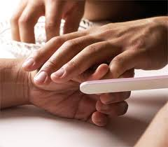
Sensational Manicure
Effervescent hand soaking, nail shaping and cuticle work, including massage,
-Your choice of polish or buffing of nails 29
French Manicure
Classic look for any occasion with hand painted white free edge. 39

Hot Oil Manicure
Deep conditioning warm essential oil treatment to penetrate
and condition natural nails and cuticles.
Excellent for cracking, peeling, or dry brittle nails or dry hard cuticles. 39

Spa Manicure
Salt glow hand expholiation treatment containing aromatherapy essential oils
including a luxurious paraffin / mask treatment 49

Gel Manicure
No chip gel polish, for a longer lasting two-four week manicure. 45

Artificial Nails
Acryl ester - Solar Nails 85
LED Light Cured - Gel Nails 85
Fills 45 French Fill 55 Nail Repair 8

Foot Care
Enjoy the Sensations of Healthy, Happy Feet using GEHWOL from
Germany - an effective foot care line, with powerful essential oils. - for Ladies & Men.

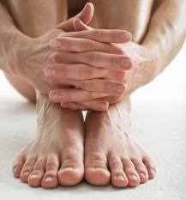
Sensational Pedicure
Herbal foot soak and massage, nail shaping, cuticles, and callus removal,
massage, choice of nail polish/ buffing nails – for Ladies & gents 79

Gel Polish Pedicure
No chip gel polish, for a long lasting pedicure polish 89

French Pedicure
Sensational Pedicure, plus the classic look for any occasion with
hand painted white free edge. 89

Spa Pedicure
The Luxurious pedicure foot treatment including bamboo scrub expholiation,
hot towels, luxurious paraffin / mask for deep hydration, 99

Gel Toenail
Nail Fungus Treatment- in a new Gel Artificial nail application. Diseased nail removal
and replacement with an anti-fungal gel allowing you to grow out nail naturally. Totally natural looking 45/Nail

